Problem 3

Let r(x)=-2x+3 and f(x) = -sin(25*pi*x) and let the program run on 25 nodes. MATLAB plot:

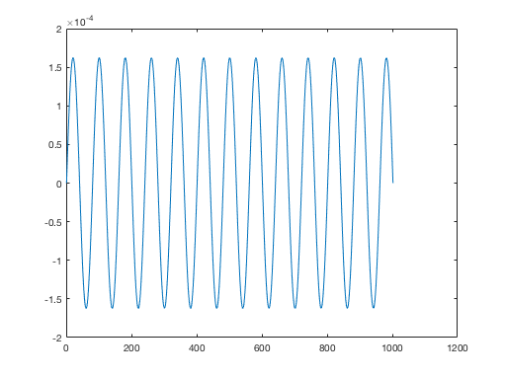

Let r(x)=-x and f(x) = -(25.0*(pi^2)I+x)*sin(5.0*pi*x); and let the program run on 25 nodes. MATLAB plot:

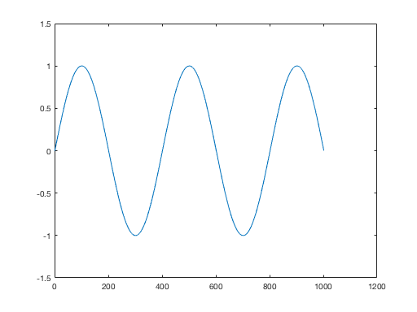

Let r(x)=-3x and f(x) = exp^(-3x); and let the program run on 25 nodes. MATLAB plot:

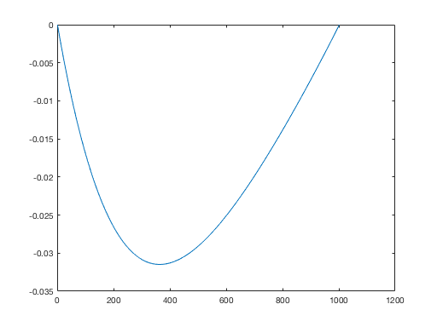

Source code:

#include <iostream>

#include <fstream>

#include <cmath>

#include <vector>

#include "mpi.h"

using namespace std;

// coefficient functions, analytical answer is u = sin(5pi*x)

double r(const double x) {

return -3*x;

}

double f(const double x) {

return exp(-3*x);

}

int main(int argc, char** argv) {

const int n = 1000, iter_max = 1000000;

const double h = 1.0/(n+1);

int rank, size, tag = 100;

MPI_Status status;

MPI_Init(&argc, &argv);

MPI_Comm_size(MPI_COMM_WORLD, &size);

MPI_Comm_rank(MPI_COMM_WORLD, &rank);

int L = n/size, R = n%size;

int I = (n+size-rank-1)/size;

int first = rank*L+min(rank, R)+1;

typedef vector<double> Vec;

Vec rr(I+2), ff(I+2);

double x_i;

for(int i = 0; i<ff.size(); ++i) {

x_i = (first-1+i)*h;

rr[i] = r(x_i);

ff[i] = f(x_i);

}

Vec u(I+2, 0), u_new(I+2, 0);

int right = rank+1, left = rank-1;

if(rank == size-1) {

right = MPI_PROC_NULL;

} else if(rank == 0) {

left = MPI_PROC_NULL;

}

for(int step = 0; step < iter_max; ++step) {

if(rank%2 == 0) { // red

MPI_Send(&u[I], 1, MPI_DOUBLE, right, tag, MPI_COMM_WORLD);

MPI_Recv(&u.back(), 1, MPI_DOUBLE, right, tag, MPI_COMM_WORLD, &status);

MPI_Send(&u[1], 1, MPI_DOUBLE, left, tag, MPI_COMM_WORLD);

MPI_Recv(&u.front(), 1, MPI_DOUBLE, left, tag, MPI_COMM_WORLD, &status);

} else { // black

MPI_Recv(&u.front(), 1, MPI_DOUBLE, left, tag, MPI_COMM_WORLD, &status);

MPI_Send(&u[1], 1, MPI_DOUBLE, left, tag, MPI_COMM_WORLD);

MPI_Recv(&u.back(), 1,MPI_DOUBLE, right, tag, MPI_COMM_WORLD, &status);

MPI_Send(&u[I], 1,MPI_DOUBLE, right, tag, MPI_COMM_WORLD);

}

// Jacobi iteration over inner points

for(int i = 1; i < u.size() - 1; ++i) {

u_new[i] = (u[i-1]+u[i+1]-h*h*ff[i])/(2.0-h*h*rr[i]);

}

u.swap(u_new); // runs in O(1)

}

const char file[] = "out";

ofstream fout;

MPI_Recv(0, 0, MPI_CHAR, left, tag, MPI_COMM_WORLD, &status);

if(rank == 0) {

fout.open(file); fout << 0 << ' ';

} // left boundary

else fout.open(file, ios::app);

for(int i = 1; i < u.size()-1; ++i)

fout << u[i] << ' ';

if(rank == size-1) fout << 0;

fout.close();

MPI_Send(0, 0, MPI_CHAR, right, tag, MPI_COMM_WORLD);

MPI_Finalize();

return 0;

}